THE BOOM YEH
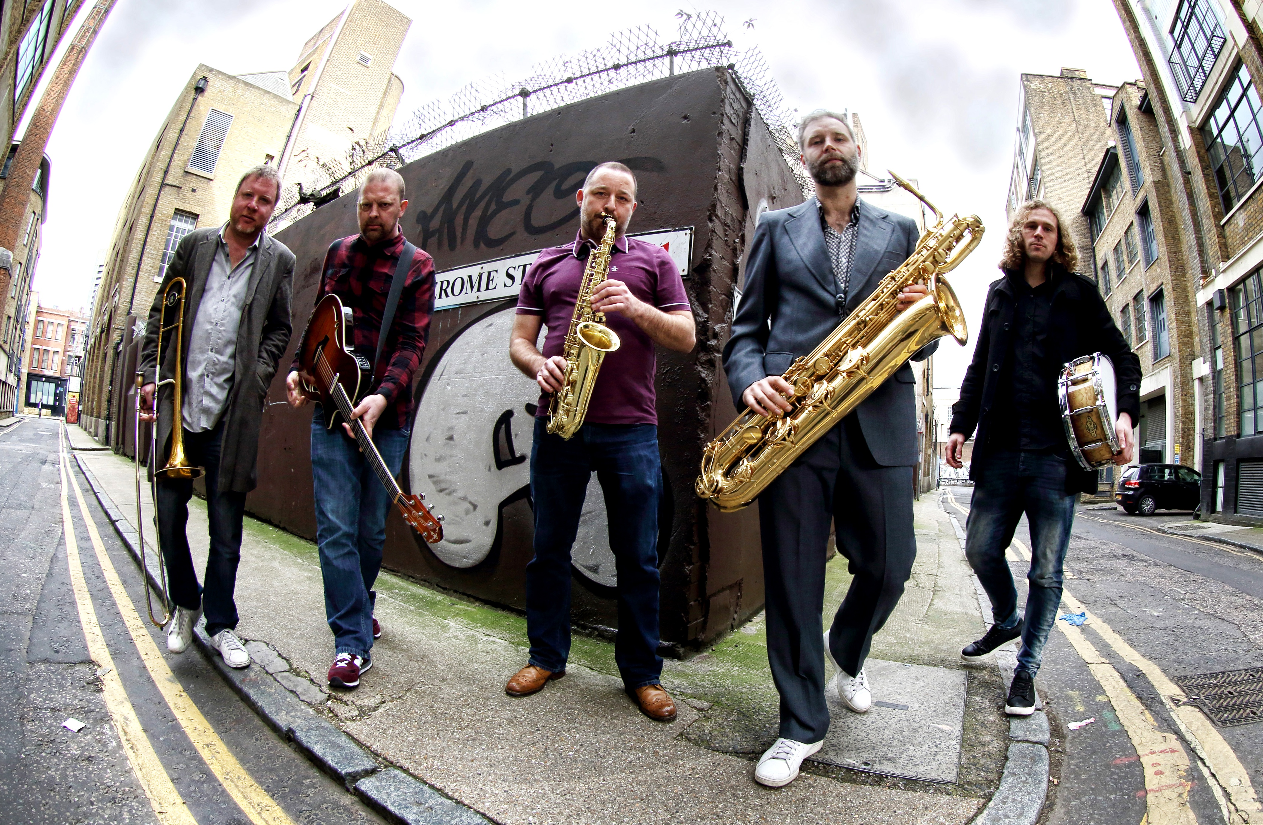

An intoxicating brew of Funk, Afro-beat, Jazz-Rock, Latin, Disco and Psychedelia –The Boom Yeh are an original London based collective that have become renowned for their high level musicianship and electrifying live performances. Their music is a finely tuned balance of tightly arranged composition and groove based improvisation.
Reverberations To Constellations their debut album released in 2013 and Darkstar E.P released in 2015 both garnered international praise and critical acclaim, receiving the support of BBC Radio 6, Jazz FM, Blues And Soul magazine and Radio/Club DJ's far and wide. An instrumental live album recorded at prestigious London venue The Hideaway is due for release in Autumn 2016.
Led by Guitarist/Composer Jon Speedy in collaboration with Saxophonist/Horn Arranger Ian Bailey, the current line-up includes drummer Alessio Barelli, bass player Matteo Grassi, trombone player Nick Mills, baritone saxophonist
Paul Silver and master percussionist Kofi Karikari.

Artists that counterpoint and inspire the band’s sound include Banda Black Rio,
The Headhunters, The Budos Band, Parliament-Funkadelic, Fela Kuti, The JB’s, Youngblood Brass Band, Weather Report, Chic and more.

“Explosive Soulful Jazz-Infused Funk. Simply awesome!” (Time Out London)

“Deep pounding and highly stylised grooves. A thunderous London powerhouse of jazz, funk, rock and afro-beat” (Blues And Soul magazine)

BOOKINGS/ENQUIRES: theboomyeh@gmail.com
WEBSITE: www.theboomyeh.com

